Considering the operator: {'V15Isotropic': {'J': 800.0, 'J1': 225.0, 'J2': 350.0}}

Using the sampler: {'MetropolisHastings': {'nflips': 1, 'nmoves': 150000, 'nsweeps': 10000, 'sweepfactor': 1.0, 'thermfactor': 0.1}}

Using the optimizer: {'SGD': {'learning_rate': 5e-05, 'schedule_multiplier': 'fixed', 'SR': {'lambd0': 100.0, 'b': 0.999, 'lambdMin': 20.0}, 'L2': {'L2_factor': 0.0001}}}

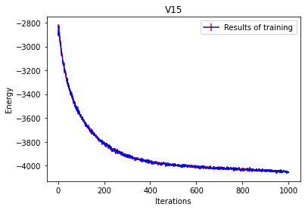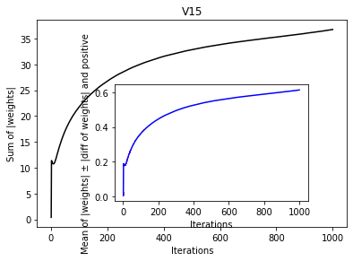

Considering the operator: {'V15Isotropic': {'J': 800.0, 'J1': 225.0, 'J2': 350.0}}

Using the sampler: {'MetropolisHastings': {'nflips': 1, 'nmoves': 150000, 'nsweeps': 10000, 'sweepfactor': 1.0, 'thermfactor': 0.1}}

Using the optimizer: {**'Momentum'**: {'learning_rate': 5e-05, 'schedule_multiplier': 'fixed', 'momentum_factor': 0.9, 'SR': False, 'L2': {'L2_factor': 0.0001}}}

